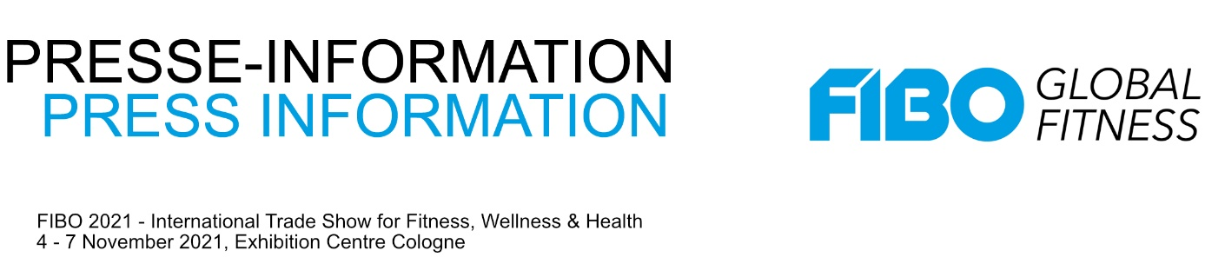
18 March 2021

Global Tech Knowledge: FitTech Summit and FIBO extend partnership

Together with the FitTech Company, FIBO 2021 is taking the offerings around new technologies, future concepts and trends to a new level. The focus of the "FitTech Summit: FIBO Edition" will include technologies that can help studio operators in the post-Corona era. This includes, for example, the technical setup of hybrid studios. Trainers will learn how they can benefit from assisting AI coaches and gamification. We will also discuss how technology can take the pressure off our future healthcare systems. The speaker program also pays attention to the global fitness market and the impact of big tech companies like Apple and Amazon entering the market.

At FIBO in November, Europe's leading conference for fitness technology and the leading international trade show for fitness, wellness and health come together. For this, they are further expanding their partnership and creating decisive added value with future topics.

Natalia Karbasova and her team of founders bring together global companies, startups and investors from the wellness, health and fitness sectors with their events to inspire them and help build long-term relationships.

FIBO will take place in 2021 from November 4-7 in Cologne, Germany. This is where fitness industry decision-makers, aspiring entrepreneurs, studio operators, trainers, healthcare stakeholders and the fitness community come together. FIBO offers international business and networking as well as a unique experience, live and digital.

www.fibo.com
www.fittechsummit.com

