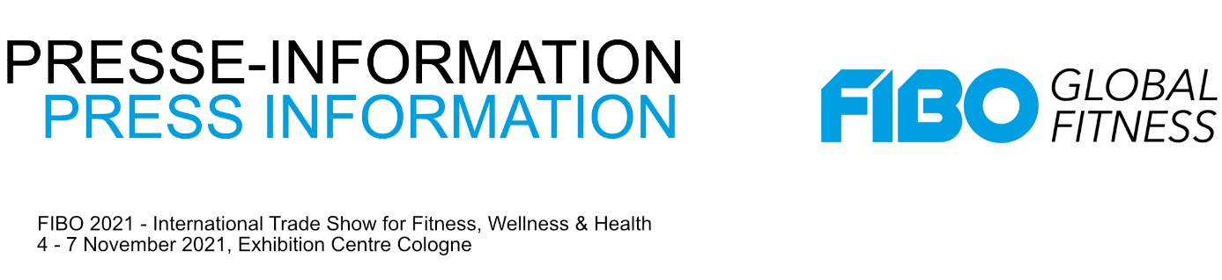

21 April 2021
DFAV Symposium at FIBO 2021:
Towards systemic relevance

Physiotherapy is systemically relevant, fitness clubs are not – this is at least the political assessment during the COVID crisis. The difference between the two? The rendering of prescription services. But how can fitness clubs better position themselves in the segment of prescribed therapy and prevention services? Get answers to this from FIBO together with the German Fitness and Aerobic Association (DFAV e.V.) as part of the leading International Trade Show for Fitness, Wellness and Health to be held in Cologne from 4 to 7 November.

In cooperation with DFAV FIBO will organise the symposium “From Subscription to Prescription – towards Systemic Relevance” developed and organised by FIBO founder Volker Ebener. It will focus on all measures in fitness studios that can lead to systemic relevance.

Building a new business line
With this FIBO delivers concrete practical knowledge for club operators seeking to develop a new line of business in the health sector: physiotherapy on machines and other therapeutic treatments whose costs are covered by health sickness funds.

Alongside the basics such as well-trained staff and corresponding equipment, systemic relevance is primarily determined by services rendered on doctor’s orders. The costs of these training units in the areas of rehabilitation and prevention can be settled by health sickness funds. The avenues to success will be presented in this symposium. There will be lectures on the role of sports physicians in fitness studios, in rehab sports, the health club of the future caught between medicine, rehabilitation and prevention and the question of how to recruit physiotherapists for fitness clubs. The event will be chaired by Prof. em. Dr. Theodor Stemper of the Institute for Sports Science at the Bergische Universität Wuppertal.

Health in focus
With this symposium FIBO strengthens the consistent expansion of the fitness market to include health. Presenting the “Meeting Point Health & Wellness”, current medical therapy and training methods in the exhibition area as well as expert talks, FIBO from 4 to 7 November 2021 will pick up on the top-themes in health. As many partners as ever will join the fray with valuable input.
www.fibo.com

